**Industry vs Serivces**

Comparing Industry sector vs Services sector over time

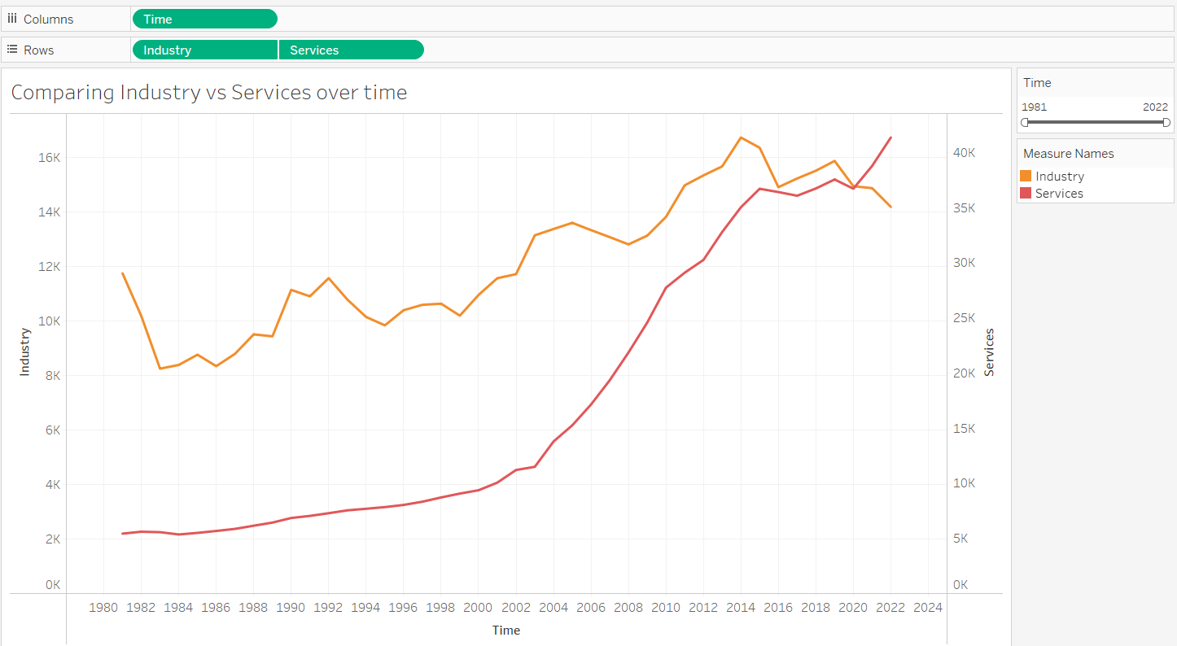

**How has the performance of the GDP compared to the industry sector changed over time?**

The green bars represent years where the percentage difference in GDP

The orange bars represent years where the percentage difference in Industry

The chart reveals periods where the industry performance either aligns with or diverges from GDP performance.

- Significant events such as economic crises and recoveries are reflected in the chart, showing their impact on both GDP and industry.

- The recent negative trends might indicate economic challenges or downturns in the industry sector, possibly due to global events or market conditions

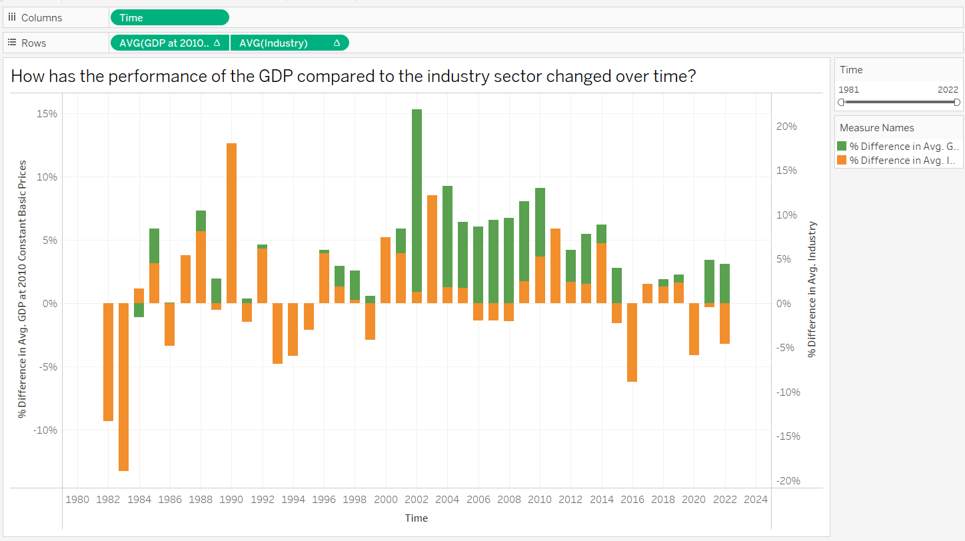

**How has the performance of the GDP compared to the service sector changed over time**

The green bars represent years where the percentage difference in GDP

The red bars represent years where the percentage difference in Services

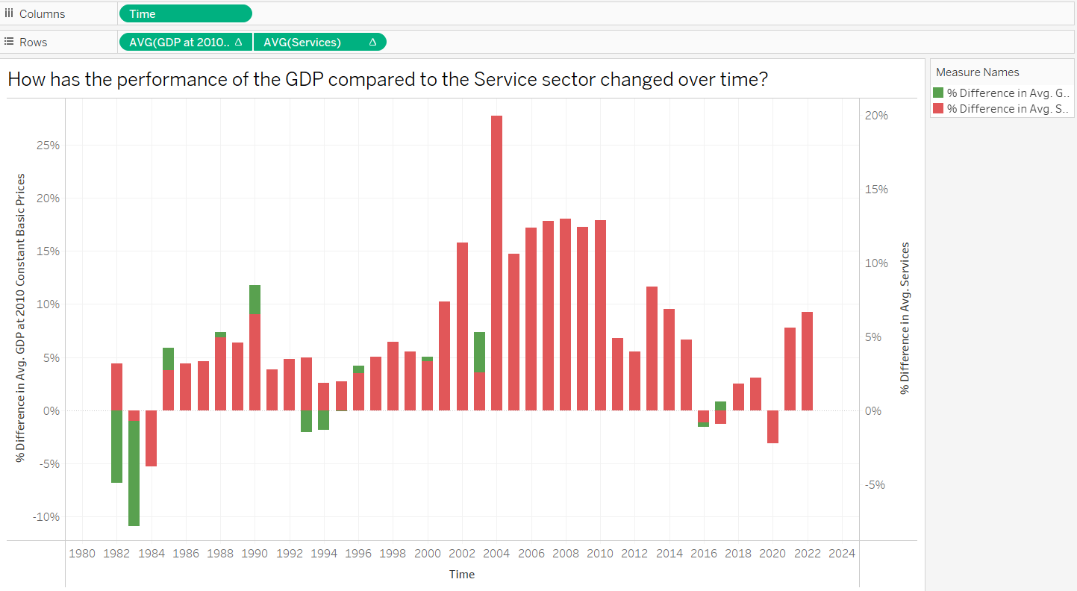

**How does the trend in GDP correlate with crude Petroleum and natural gas Production?**

* The chart uses running sums, which accumulate values over time, demonstrating how total production and GDP have increased cumulatively.
* The running sum for crude petroleum and natural gas shows a steady and significant increase, especially after 2000
* There is a positive correlation between the increase in crude petroleum and natural gas production and GDP growth. As the production of these resources has increased, the GDP has also shown a consistent upward trend.

.

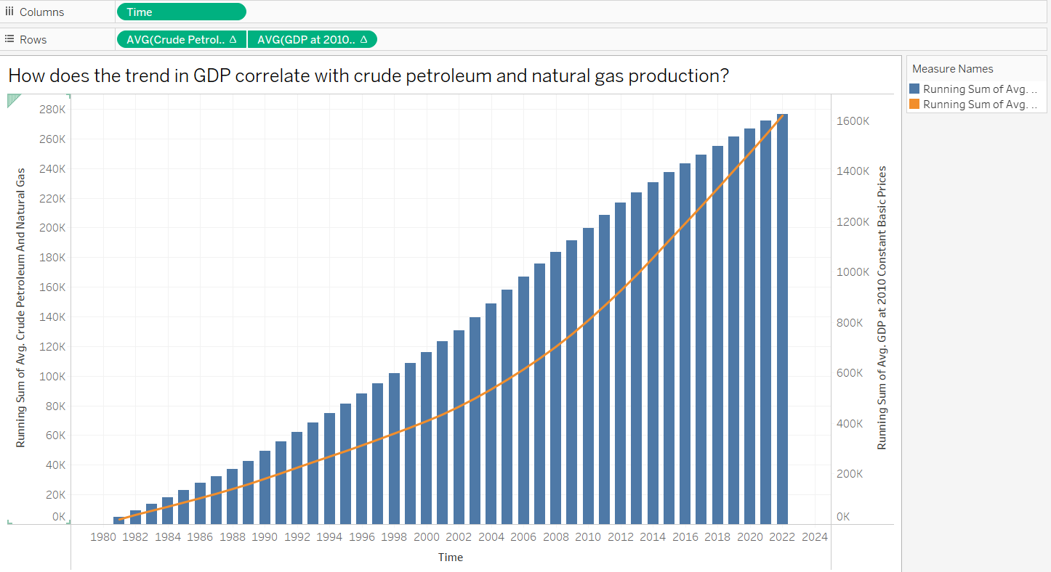

**Growth Rate of GDP and Trade over time**

The chart illustrates the cumulative growth of trade and GDP over time. It shows how trade activities and economic output, measured by GDP, have evolved from 1980 to 2024. Using running sums emphasizes the cumulative increase in trade and GDP over the years.

